1. Normalizer nadare
2. Documentation nadare
3. Encapsulation nadare
4. Global variable eshtebas
5. Modulation nadare
6. Input maker nadare (phi 1)
7. Visualization nadare
8. Git control nadare
9. Test nadare
10. Log nadare

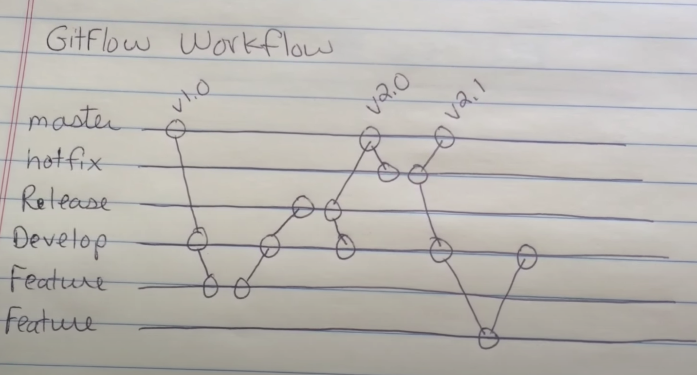

Suggestion:

1 – connect to supercomputers

2 – connect to quantum computers

000 0.9

001 0.0

010 0.0

011 0.0

100 0.0

101 0.1

110 0.0

111 0.0